Name: Mark James M. Fiel
Year & Sec: 3rd - B

“Individual Activity4: “Design Your Own System Using UML”

Part 1: System Idea & Recall
- Four UML Diagrams.
- Use Case Diagram – Shows the users of the system and the actions they can perform. It helps identify the main functions of the system.
- Activity Diagram – Shows the step-by-step flow of a process. It helps explain how the system works from beginning to end.
- Class Diagram – Shows the classes, attributes, methods, and relationships in the system. It helps describe the structure of the system.
- Sequence Diagram – Shows how users and system components interact in order. It focuses on the sequence of actions or messages.
- System Title.
“Beach Resort Booking System”

Short Description
The Beach Resort Booking System is a simple application that allows customers to reserve cottages, rooms, and beach facilities online. Customers can choose their preferred schedule, view available accommodations, and confirm bookings through the system. Resort staff can manage reservations and update booking statuses. This system helps make the reservation process faster, more convenient, and more organized.organized.
Main Features:
- Customer registration and login
- Online booking reservation
- View available cottages and rooms
- Booking confirmation and status tracking
- Resort staff management of reservations
Part 2: UML Diagram Creation
- Use Case Diagram.
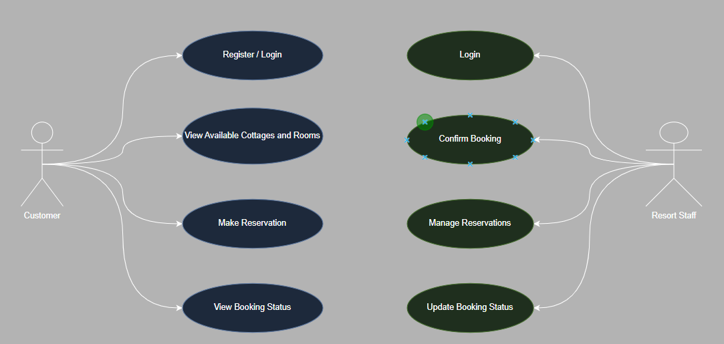

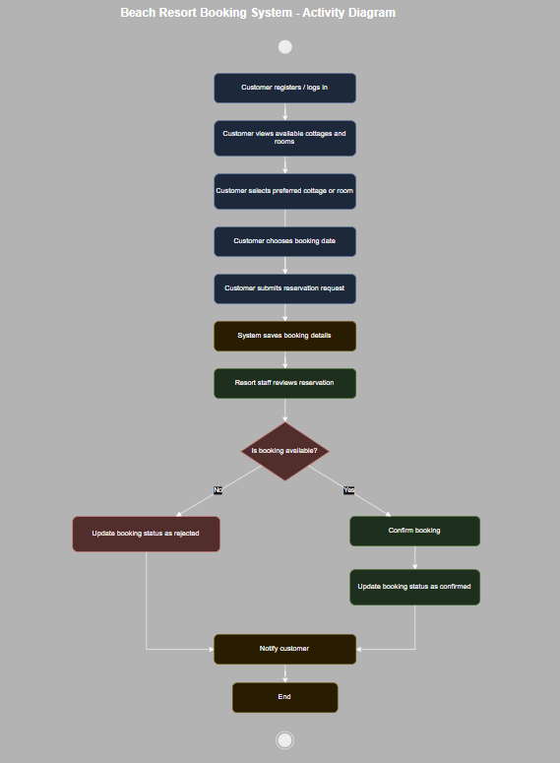
- Activity Diagram.

Part 3: SDLC Application
Planning:
In the planning phase, the purpose of the Beach Resort Booking System is identified. The features, users, and booking process are planned carefully.
Design:
In the design phase, UML diagrams are created to show how the system will work. The interface design, booking flow, and database structure are also prepared.
Implementation:
In the implementation phase, the system is developed using programming tools. Features such as customer login, booking reservation, and reservation management are created.
Testing:
In the testing phase, the system is tested to ensure all features work properly. The booking process, login system, and reservation updates are checked for errors.
Part 4: Reflection
- What did you learn from creating UML diagrams?

I learned that UML diagrams help explain the structure and flow of a system clearly. They make system development easier to understand and organize.

- Why is planning important before building a system?

Planning is important because it helps identify the needs and possible problems of the system before development starts. It also helps developers create the system more efficiently and accurately.

